An Overview of Radiation Safety: Radiation Physics and Radiobiology

Author: Kelli Welch Haynes, Ed.D, RT (R), FASRT, FAEIRS

Outline

Introduction

Radiation Physics and Radiobiology
  - Principles of Radiation Physics
    - x-ray production
      - source of free electrons
      - acceleration of electrons
      - focusing of electrons
      - deceleration of electrons
    - target interactions
      - bremsstrahlung
      - characteristic
    - x-ray beam
      - frequency and wavelength
      - beam characteristics
        - quality
        - quantity
        - primary versus remnant (exit)
      - inverse square law
      - fundamental properties (e.g., travel in straight lines, ionize matter)
    - photon interactions with matter
      - photoelectric
      - Compton
      - coherent (classical)
      - attenuation by various tissues
        - thickness of body part
        - type of tissue (atomic number)
  - Biological Effects of Radiation
    - SI Units of measurement
      - absorbed dose (Gy)
      - dose equivalent (Sv)
      - exposure (C/kg)
      - effective dose (Sv)
      - air kerma (Gy)
    - radiosensitivity
      - dose-response relationships
      - relative tissue radiosensitivities (e.g., LET, RBE)
      - cell survival and recovery (LD50)
      - oxygen effect
    - somatic effects
      - cells
      - tissue (e.g., eye, thyroid, breast, skin, marrow, gonad)
      - embryo and fetus
      - carcinogenesis
      - early versus late or acute versus chronic
      - deterministic (tissue reactions) versus stochastic
      - short-term versus long-term exposure
    - acute radiation syndromes
        - hemopoietic
        - gastrointestinal (GI)
        - central nervous system (CNS)

Learning Objectives
- Discuss principles of radiation physics including x-ray production
- Differentiate between the target interactions of characteristic and bremsstrahlung radiation.
- Delineate the characteristics of the x-ray beam
- Differentiate between the interactions with matter
- Discuss biological effects of radiation, including units of measurement, radiosensitivity and somatic effects.

Introduction
Today, more than ever, patients demand high-quality care and accountability from their healthcare providers. So medical professionals must assess their knowledge and skills routinely. By doing so, they become better prepared to meet changing standards. This is why many credentialing organizations, including the agency that certifies radiologic technologists (RTs), have created long-term requirements, sometimes called time-limited certification, to maintain credentials. The American Registry of Radiologic Technologists (ARRT) started this process for graduates that completed a radiologic science program after 2010. So, the process is called Continuing Qualification Requirements (CQR). CQR helps radiologic technologists identify skills and gaps in their knowledge and skills that could cause them to fall behind today's entry-level qualifications. CQR enables you to refresh your knowledge, understanding, and ability. CQR applied to all registered radiologist assistants (RRAs) and RTs who earned their credentials on or after January 1, 2010. RTs have three years to complete the CQR process. ARRT will notify you through your online account when your compliance window opens. You will then access your online CQR tools to guide you through three steps. First, you will complete a professional profile and then take the structured self-assessment (SSA), which utilizes the same content specifications as the radiography examination. Lastly, you will be prescribed continuing education (CE) to complete if the SSA reveals gaps. The prescribed CE activities can also count toward your biennial CE requirement.

Continuing qualifications requirements (CQR) assist registered technologists in documenting their continued qualifications in the disciplines of certification and registration.¹ To accomplish this purpose, the CQRs are presented in three parts: the professional profile, the structured self-assessment (SSA), and continuing education (CE). The CQR SSA aims to assist registered technologists in identifying gaps in the knowledge and cognitive skills underlying the intelligent performance of the tasks typically required for practice within the disciplines of certification and registration held and help direct their professional development efforts. The SSA Content Specifications for Radiography are provided to assist radiographers during their CQR compliance period. Its purpose is to prepare radiographers for the SSA and to help education providers develop coursework for the radiographers who need to address specified areas with targeted continuing education. Targeted CE is assigned only if a standard is not met in a category on the SSA. The SSA is composed of questions designed to evaluate an individual's knowledge of topics related to current practice. Table 1 presents the major categories and subcategories covered on the SSA. The number of questions in each category is listed in bold, and the number of questions in each subcategory is in parentheses. The potential number of targeted CE credits that would be prescribed if the standard is unmet are across from each subcategory, with the maximum amount listed at the bottom. Specific topics within each category are addressed in the content outline.

Table 1: Radiography Content Specifications
Content Category | Number of Questions | Potential CE Credits
Patient Care  Patient Interactions and  Management (10) | 10 | 6
Safety  Radiation Physics and  Radiobiology (10)  Radiation Protection (10) | 20 | 4  5
Image Production  Image Acquisition and  Evaluation (10)  Equipment Operation and  Quality Assurance (10) | 20 | 4  5
Procedures  Head, Spine, and Pelvis  Procedures (10)  Thorax and Abdomen  Procedures (10)  Extremity Procedures (10) | 30 | 3  4  5
 | Total 80 | Maximum CE 36

This article follows the first section of the Safety, Radiation Physics, and Radiobiology outline of the content specifications for Radiography as published by the ARRT.

Radiation Physics and Radiobiology

Principles of Radiation Physics²
Radiation is energy that comes from a source and travels through space at the speed of light. ​Ionizing radiation consists of particles, x-rays, or gamma rays with sufficient energy to cause ionization in the medium through which it passes.​ Because of this process, the ionization event may cause injury in normal biologic tissue. ​Therefore, radiologic technologists' must minimize patient exposure to radiation.​
Radiation protection aims to protect persons from both short-term and long-term effects of radiation.​RTs are responsible for ensuring radiation safety during all medical radiation procedures. ​Radiation protection is effective measures to safeguard patients, personnel, and the general public from unnecessary exposure to ionizing radiation.

X-ray production2
What is needed to produce an x-ray?​ X-rays are produced when electrons strike a metal target. The electrons (from the cathode) are liberated from the heated filament and accelerated by a high voltage towards the metal target. The x-rays are produced when the electrons collide with the atoms and nuclei of the metal target (the anode).​ There are four essential conditions for the production of x-rays​. First, there must be a source of free electrons from the cathode through thermionic emission​. Next, there must be a means of accelerating those electrons to extreme speeds​. Then, the electrons must be focused. Lastly, there must be a means of decelerating the electrons, which happens when the electrons strike the anode.

Target interactions²
Target interactions take place in the anode of the x-ray tube.​ A projectile electron entering the anode target material penetrates its atoms. Since atoms are mostly space, the projectile electron can pass through several atoms before striking anything.​ When an atom does strike something, there are two possibilities: The projectile electron may interact with an orbital electron (characteristic radiation), or it may interact with the nucleus of an atom (Bremsstrahlung radiation). Both interactions result in the production of x-rays but by very different processes.

Bremsstrahlung radiation²
Bremsstrahlung is German for "braking radiation." If the electron passes near the atomic nucleus, the positive attraction of the nucleus will cause it to brake or slow down. This deceleration of the electron represents a loss of energy, and that lost energy is emitted as an x-ray photon. ​As the electron decelerates, the arc of its deceleration determines the energy of the x-ray that is produced. ​If there is a slight change in direction, a low-energy x-ray photon is produced. If there is a drastic change in direction, a high-energy x-ray photon is produced. Bremsstrahlung x-rays account for the vast majority of the overall x-ray beam. Bremsstrahlung is responsible for the heterogeneous or poly-energetic nature of the x-ray beam, which contributes to differential absorption by body tissues and provides for subject contrast in the remnant beam. Without subject contrast, producing diagnostic images with x-rays would be impossible. With x-rays of many energies, subtle tissues such as fat pads and bone marrow can absorb different portions of the beam so that they are demonstrated in the final image. Filtration removes most of the low-energy x-rays from the x-ray beam that are ultimately emitted from the collimator​. Once filtration occurs, the x-ray beam is left with an average kilovolt peak (kVp) of about 1/3 of the set kVp.

Characteristic radiation²
Characteristic radiation is created from an interaction with orbital electrons. A projectile electron ionizes the tungsten atom and ejects an orbital electron from its shell​. The orbital electron is repelled away from the projectile electron when it approaches. The dropped electron loses energy, which is emitted as a characteristic x-ray. It is called characteristic because it is a characteristic of the element that produces the photon and represents the energy at the binding level of that orbital shell.​ When the electron is ejected, it gives off the energy at that binding level. ​This energy is the difference between the binding energies for the two shells.

The X-ray Beam²
Radiation is energy that comes from a source and travels through space at the speed of light. This energy has an electric and magnetic field associated with it and has wave-like properties. However, x-ray photons behave more like particles than waves. Since x-ray photons exhibit both behavior types, this is known as wave-particle duality.

Frequency and wavelength²
Frequency is the number of wavelengths that pass a point per second.​ Wavelength is the distance from one crest to another or from one valley to another.​ The shorter the wavelength, the higher the frequency. Frequency and wavelength are inversely proportional to each other. Frequency and wavelength are important because they affect the energy of the beam. The energy of a photon is directly proportional to its frequency. ​X-radiation has a higher frequency and a shorter wavelength than visible light. This difference determined how these photons interact with matter.

Beam characteristics
The x-ray beam is characterized by quantity (the number of x-rays in the beam) and quality (the penetrability of the beam). ​

Quality3
Kilovoltage (kV) is a measure of the electrical force or pressure behind a current of electricity, which causes it to flow. It is a measure of electrical energy. The more pressure that is exerted on the electrons to flow, the greater the energy pushing the current, and the higher kV will be measured. The primary purpose for adjusting kVp is to set the penetration level of the x-ray beam. Kilovolt peak (kVp) controls the quality of the x-ray beam. As the energy of an x-ray beam is increased, the penetrability is also increased. High-energy x-rays can penetrate tissue more deeply than low-energy x-rays. As the kVp is increased, so is the x-ray beam quality. ​

Quantity3
Milliamperage (mA) measures the quantity of electrical current flowing through a circuit. Milliamperage per second (mAs) controls the number of photons in the x-ray beam. The number of x-rays in the useful beam is the radiation quantity. X-ray quantity is directly proportional to mAs. When mAs is doubled, the number of electrons striking the tube target is doubled, and therefore, the number of x-rays emitted is doubled. ​

Primary versus remnant (exit)³
The x-ray beam may be divided into two portions: the primary beam and the remnant beam. The primary beam is the radiation emitted by the x-ray tube that has not yet passed through the patient or object being studied. Its passage through atmospheric air does not significantly alter the quality of the primary beam as it travels toward the object.

The remnant beam is the radiation that emerges from the body tissue behind the patient or object and strikes the image receptor. Remnant radiation is image-forming radiation. Although the remnant beam includes rays from the primary beam that have passed through the body unaffected, it also contains secondary and “scattered” radiation emitted by the tissues. Scattered radiation is random in its direction, resulting in unwanted exposure across the image receptor and can degrade the information in the signal carried by the useful remnant beam.

Inverse square law²
When light is emitted from a source such as the sun or a light bulb, the intensity decreases rapidly with the increased distance from the source. ​ X-rays exhibit the same property. ​This decrease in intensity is inversely proportional to the square of the distance from the object from the source. ​Mathematically, this is the inverse square law and is expressed in this formula: ​

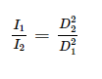
Where I₁ is the intensity at D_{1,} from the source, and I₂ is the intensity at distance D₂ from the source.

Figure 1 demonstrates the inverse square law. The rapid decrease in intensity with increasing distance is because the total light, or radiation, spreads out over a larger distance. ​Therefore, the intensity of the radiation follows Newton's Inverse Square Law. This law accounts for the fact that radiation intensity becomes weaker as it spreads out from the source since the same amount of radiation spreads over a larger area.

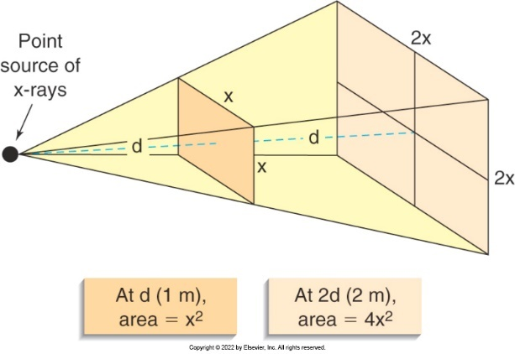
Figure 1
When the distance from a point source of radiation is doubled, the radiation at the new location spans an area four times larger than the original area. However, the intensity at the new distance is only ¼ of the original intensity.
Image reference: Statkiewicz Sherer MA, Visconti PJ, Ritenour ER, Haynes, KW. Radiation Protection in Medical Radiography. 9th ed. (2022). St. Louis, MO: Mosby Elsevier.

Fundamental Properties of X-rays
The fundamental properties include the following:
- Packets of energy
- Highly penetrating rays
- Travel in waves along a straight line
- Electrically neutral
- Move at the speed of light
- X-rays cannot be focused on a single point
- A magnetic or electric field cannot deflect X-rays
- Produce an electric and magnetic field at right angles to their path
- X-rays can penetrate liquids, solids, and gases
- Absorbed by matter
- Cause ionization in atoms
- Capable of fluorescence
- Contain properties of attenuation absorption and scattering

Photon interactions with matter³
Image visibility depends entirely on the interactions of the x-rays with the atoms inside the patient, which is controlled electrically. Individual photons can be transmitted, scattered, or absorbed. Attenuation is the product of absorption and scatter. Three possible interactions between x-rays and atoms occur in the diagnostic energy range: Coherent, Compton, and Photoelectric.

Photoelectric absorption⁴
Photoelectric (PE) absorption is an interaction between an x-ray photon and an inner-shell electron. PE absorption occurs with higher energy x-rays, typically in the 23-150 kVp. X-rays in this energy range are more likely to penetrate through the tissue and not interact​. PE absorption is the most crucial interaction between x-ray photons and the atoms of the patient's body for producing useful images​. The x-ray is absorbed​, and an electron is ejected.

Compton scattering⁴
Compton scattering is an interaction between an x-ray photon and an outer-shell electron. Compton scattering typically occurs with x-rays in the moderate energy range, usually 60 to 90 kVP. Compton scattering is responsible for the scatter radiation that is produced. An incoming x-ray photon interacts with an outer shell electron of the irradiated object. The freed electron has kinetic energy and can ionize atoms. The photon changes direction, loses energy, and recombines with an atom that needs another electron. The x-ray photon that surrendered some energy continues in a new direction, and the photon can also emerge from the patient and contribute to noise on the image receptor and dose to the RT. Compton scattering is a significant source of noise on the image, patient dose, and technologist dose.

Coherent scattering⁴
Coherent scattering is an interaction between an x-ray photon and an atom. Coherent scattering occurs with low-energy x-rays ranging from 1 to 50 kVp. A photon of low energy interacts with the entire atom. The atom absorbs the photon and becomes excited. The atom gives off a photon with the same wavelength and energy. The x-ray loses no energy and only changes direction. Coherent scattering contributes to noise or fog, in the form of scatter, on the image. Coherent scattering is the least likely interaction to affect body tissue because it does not have enough power to penetrate the atoms of the patient's body.

Attenuation by various tissues²
The reduction in the number of x-rays remaining in an x-ray beam after penetration through a given thickness of tissue is attenuation. When a broad beam of x-rays is incident on any tissue, some x-rays are absorbed, and some are scattered. Photoelectric absorption results in light areas on the image, while transmitted x-rays result in dark areas​. These two processes create the image.​

Two factors affect differential attenuation; the thickness of the body part and its atomic number (Z)​.
A thicker structure will absorb twice as many photons as a thinner structure. Tissues of higher atomic numbers will absorb more radiation than tissues with low atomic numbers.

Biologic Effects of Radiation

SI Units of Measurement⁴
Radiologic technologists must have a clear understanding of the fundamental radiation quantities. The quantities are absorbed dose (D), dose equivalent (EqD), exposure (X), effective dose (EfD) and air kerma.

Absorbed dose (D)⁴
As ionizing radiation passes through an object such as tissue, some of the energy of that radiation is absorbed by the body and stays within it. Absorbed dose is the amount of energy per unit mass absorbed by the patient's tissue. D is measured in milligray (mGy).​

Dose equivalent (EqD)⁴
The dose equivalent considers the type of ionizing radiation that was absorbed. In diagnostic radiology, absorption is caused by x-rays. EqD is measured in millisieverts (mSv). EqD is a product of the average absorbed dose in a tissue or organ and its associated weighting factor. ​

Exposure (X)⁴
Exposure is defined as the total electrical charge of one sign, either all plus or all minus, per unit mass that x-ray photons generate in dry air. Exposure is measured in coulomb per kilogram (C/kg).​

Effective dose (EfD)⁴
Effective dose is the best measure for the overall risk of exposure to humans from ionizing radiation. EfD incorporates the effect of the type of radiation used and the variability in radiosensitivity of the specific organ or body part irradiated through appropriate weighting factors. EfD is measured in millisieverts (mSv).

Air Kerma⁴
Kerma is an acronym for kinetic energy released per unit mass (kg) of air. It is a calculation of radiation intensity in the air. Air Kerma is another quantity that is used to express how energy is transferred from a beam of radiation to air. The field is transitioning to use of air Kerma in place of using exposure to measure quantity. Because of this, x-ray tube output and inputs to the image receptors are now expressed in air kerma. Air kerma is measured in milligrays (mGy).

Radiosensitivity⁴
The human body is composed of different types of cells and tissues, which vary in their degree of radiosensitivity, meaning some cells and tissues are more sensitive to the effects of radiation than others. When radiation damage appears at the whole-body level, this results from damage to organ systems, which are a consequence of radiation damage to cells of that particular system.​ ​Immature cells are nonspecialized and undergo rapid cell division​; therefore, they are significantly more radiosensitive than mature cells.​ Conversely, mature cells are specialized and divide slower, if at all​; therefore, they are considered less radiosensitive. Deoxyribonucleic acid (DNA), located in the cell's nucleus, is the cell's most radiosensitive part.

As far as tissues of the body, lymphocytes (white blood cells), spermatogonia, erythrocytes (red blood cells), and intestinal crypt cells (mucosal glands of the small intestine) are highly radiosensitive. ​​Muscle cells, nerve cells, and chondrocytes (produce cartilage) are considered as low radiosensitivity. ​​Neither patients' blood nor the blood-forming organs should undergo appreciable damage from radiation exposure received during diagnostic imaging procedures. ​​However, studies indicate some chromosome aberrations in circulating lymphocytes that have received radiation doses within the diagnostic radiology range. This response has been seen in high-level fluoroscopy procedures such as heart catheterization and other invasive procedures.

The Law of Bergonie’ and Tribondeau states that the most pronounced radiation effects occur in cells with the least maturity specialization or differentiation, the greatest reproductivity, and the most prolonged mitotic phases.​The law is true for all somatic and germ cells.

Dose-response relationships²
The radiation dose-response relationships are demonstrated graphically through a curve that maps the observed effects of radiation exposure related to the dose of radiation received. Generally, as the dose increases, so does the response, but that response may or may not be directly proportional, and there may be some doses below which no response is seen. The dose-response curve is either linear (straight line) or nonlinear (curved to some degree) and depicts either a threshold or nonthreshold dose. (Figure 2).

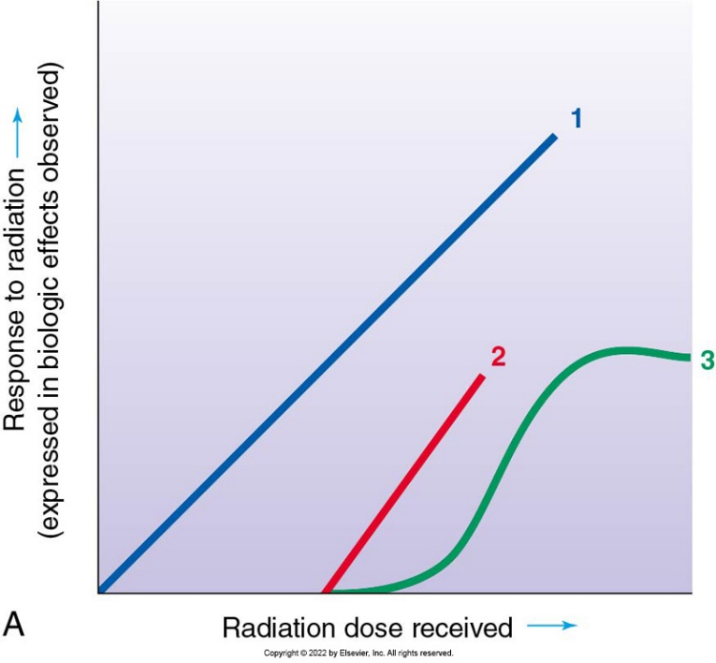

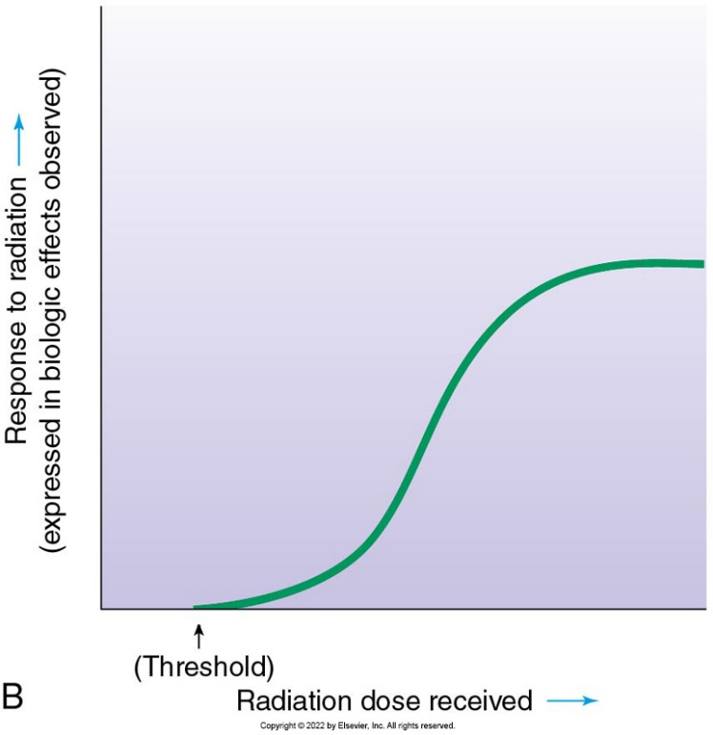
Figure 2 (A) 1. represents a linear (straight-line) nonthreshold curve of the radiation dose-response relationship. 2. represents a linear threshold curve of radiation dose-response relationship; 3. Represents a nonlinear threshold curve of radiation dose-response relationship. (B) Sigmoid (S-shaped, hence nonlinear) threshold curve of radiation dose-response relationship.
Image reference: Statkiewicz Sherer MA, Visconti PJ, Ritenour ER, Haynes, KW. Radiation Protection in Medical Radiography. 9th ed. (2022). St. Louis, MO: Mosby Elsevier.

Threshold​ and Nonthreshold, Linear and Nonlinear relationships
The term threshold is a point or level at which a response or reaction to increasing stimuli occurs.​Regarding ionizing radiation, this means that below a certain absorbed radiation dose, no biologic effects are observed.​ The biologic effects begin to occur only when the threshold dose is reached.​
​
A nonthreshold​ relationship indicates that radiation absorbed of any dose can potentially produce a biologic effect.​ Therefore if the dose-response curve is as shown in Figure 3, biologic effect responses will be caused by ionizing radiation in living organisms in a directly proportional manner at any dose above zero. This behavior is referred to as a linear threshold (LNT) relationship. LNT indicates that no radiation dose can be considered safe, with the incidence of the biologic effects increasing directly with the magnitude of the absorbed dose.

In a linear dose-response relationship, the straight line indicates that the response to radiation is directly proportional to the radiation dose. A nonlinear or sigmoid line demonstrates that the response to radiation is not directly proportional to the radiation dose.

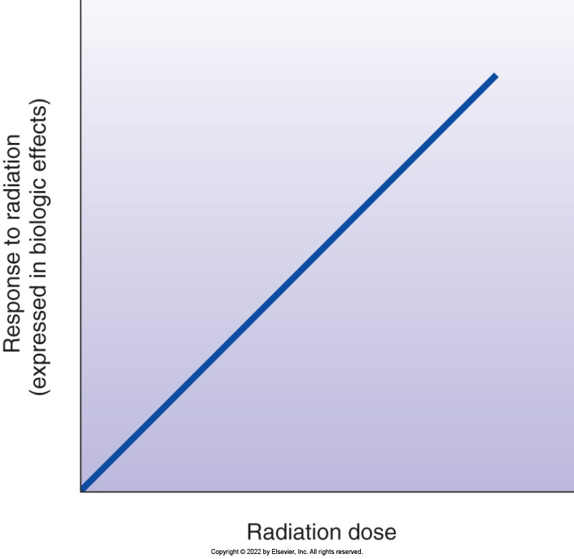
Figure 3 Linear nonthreshold curve of radiation dose-response relationship. The straight-line curve passing through the origin in the graph indicates that the response to radiation (in terms of biologic effects) is directly proportional to the radiation dose and that no known level of radiation dose exists below which the chance of sustaining biologic damage is zero.
Image reference: Statkiewicz Sherer MA, Visconti PJ, Ritenour ER, Haynes, KW. Radiation Protection in Medical Radiography. 9th ed. (2022). St. Louis, MO: Mosby Elsevier.

Relative tissue radiosensitivities⁴
The characteristics of radiation, such as charge, mass, and energy, vary among the different types of radiation.​ These characteristics can affect the amount of biologic damage and determine the extent to which different radiation modalities transfer energy into biologic tissue.​ To be able to understand how ionizing radiation causes injury in biologic tissue, three concepts must be studied; ​Linear energy transfer (LET), Relative biologic effectiveness (RBE), and Oxygen enhancement ratio (OER).

Linear energy transfer can determine the ability of radiation to cause biologic damage in human tissue. ​Electrons ejected due to photoelectric absorption and Compton scattering move through tissue and deposit, or transfer, energy through ionization. LET is the rate at which an electron transfers energy to the surrounding tissue. ​ LET is the energy deposited per unit of a track​, and it is used to assess potential tissue and organ damage from exposure to ionizing radiation.​ The total length of the track calculates the energy average. The energy transfer rate from ionizing radiation, used for diagnostic purposes (x-rays), to soft biologic tissue is considered low-LET radiation. As the LET increases, the biologic response increases. Table 2 lists the categories of LET.

Table 2: General Categories of Linear Energy Transfer (LET)
Low-LET Radiation | High-LET Radiation
Gamma rays | Alpha particles
X-rays | Ions of heavy nuclei
Electrons | Charged particles released from interactions between neutrons and atoms
 | Low-energy neutrons

Biologic damage produced by radiation escalates as the LET of radiation increases. Identical doses of radiation of different LETs do not render identical biologic effects. Relative biologic effectiveness (RBE) describes the comparative capabilities of radiation with differing LETs to produce a particular biologic reaction. For example, 1 gray of neutrons has a more significant biologic effect than 1 gray of x-rays. ​RBE is a ratio of the dose of reference radiation to the dose of radiation necessary to produce a response.

The oxygen enhancement ratio (OER), or oxygen effect, refers to the enhancement of the therapeutic or detrimental effect of radiation due to the presence of oxygen. ​When tissue is irradiated in an oxygenated state, the tissue is more sensitive to radiation​. OER is an essential concept in radiation therapy. The OER is the ratio of the radiation dose required to cause a particular biologic response of cells in an oxygen-deprived environment compared to the radiation dose needed to generate an identical response under normal oxygenated conditions.​ Diagnostic x-ray imaging is performed under conditions of full oxygenation.

Cell survival and recovery
The number of cells that survive after exposure to ionizing depends on the radiation dose. The lethal dose ​(LD) 50 signifies the whole-body dose of radiation that can be lethal to 50% of the exposed population. LD 50/30 or LD 50/60 indicates the lethal dose in 30 or 60 days. The LD 50/30 for adults is estimated to be 3-4 Gy without medical treatment. ​With medical support, humans have tolerated doses as high as 8.5 Gy​. Because cells contain inherent repair mechanisms, repair and recovery may occur when exposed to sublethal ionizing radiation doses.​ After irradiation, surviving cells begin to repopulate, allowing an organ to regain some of its functional ability.

d. Oxygen effect
See Oxygen enhancement ratio.

Somatic effects³
The term somatic originates from the Greek term “soma” meaning “body.” Therefore, somatic effects are those which occur in the exposed individual. Genetic effects are effects upon future generations due to the irradiation of germ cells in previous generations. The ​primary consequence is cancer. ​

Cells³
For the cell as a whole, damage to the cell’s nucleus reveals itself in one of the following conditions:
1. Instant death-the cell dies​.
2. Reproductive death- the cell does not perish but can no longer reproduce​.
3. Apoptosis or programmed cell death-some cells die for the good of the organism​.
4. Mitotic, or genetic, death occurs when a cell dies after one or more divisions​.
5. Mitotic delay-mitosis is delayed​.
6. Interference with function- can be temporary or permanent, depending on the dose.

bTissue³
The more mature and specialized in performing functions a cell is, the less sensitive it is to radiation.
Effects on the eyes: cataractogenesis. Cataracts are an opacity of the eye lens​. Cataractogenesis is the production or origin of cataracts.​ There is a high probability that a single dose of radiation of about 2 gray will induce the formation of cataracts. ​A dose of 2 Gy results in partial or complete vision loss​. Radiation-induced cataracts follow a threshold, nonlinear dose-response relationship
Effects on the thyroid: Radiation can cause thyroid cancer. The thyroid is one of the most radiosensitive tissues. Children are much more sensitive to thyroid irradiation than are adults.
​Effects on the breast: Female breast tissue is highly sensitive to the carcinogenic effects of radiation, particularly when exposure occurs at a younger age.
Effects on the skin: Radiation exposure can damage the basal cell layer of the skin and result in inflammation, erythema and/or desquamation. In addition, radiation damage to the hair follicles can cause epilation.
Effects on bone marrow: can lead to bone marrow failure and eventually death.
Effects on the gonads: temporary or permanent sterility. The reproductive cells (germ cells) are relatively radiosensitive. The person is more radiosensitive when they are younger​. A dose of 2 Gray can cause temporary sterility for females and males, which could last as long as 12 months​. Permanent sterility may be seen with a dose of 5 Gray.

Embryo and fetus³
The fetus is very sensitive to radiation because it comprises rapidly dividing, immature cells.​The fetus is most susceptible to radiation during the first trimester of pregnancy. ​Fetal radiosensitivity decreases as gestation progresses.​There appears to be a threshold of about 0.1 Gy for fetal damage. Routine diagnostic procedures never reach this level.

Carcinogenesis²
Carcinogenesis is the production or origin of cancer​. Cancer is the most critical late somatic effect. Experiments with animals and statistical studies of human populations have shown that radiation causes cancer.​ At high doses, for groups such as the atomic bomb survivors, the risk is measurable.​ At low equivalent doses, below 0.1 sievert, which includes groups such as occupationally exposed individuals and virtually all patients in diagnostic radiology, this risk is not directly measurable in population studies. ​Distinguishing radiation-induced cancer is difficult because it does not present any different than other cancers.

Early versus late or acute versus chronic⁴
Depending on the length of time from the moment of irradiation to the first appearance of symptoms of radiation damage, somatic effects are classified as either early or late. Early tissue reactions may appear within minutes, hours, days, or weeks following a substantial dose of ionizing radiation. Possible high radiation dose consequences include:
- Nausea
- Fatigue
- Erythema (redness of the skin)
- Epilation (loss of hair)
- Blood disorders
- Intestinal disorders
- Fever
- Dry and moist desquamation (shedding of the outer layer of skin)
- Depressed sperm count in males
- Temporary or permanent sterility in males and females (dependent on the dose)

Radiation-induced at the cellular level may lead to measurable somatic and genetic damage in the living organism later in life. These late effects are the long-term results of radiation exposure. Measurable late biologic damage includes cataracts, leukemia, and genetic mutations.

Deterministic (tissue reactions) versus stochastic²
If the radiation response increases in severity with increasing radiation dose, it is a deterministic effect and occurs within days after the radiation exposure. However, if the incidence of the radiation response increases with increasing radiation dose, it is a stochastic effect and is not observed for months or years.

Short-term versus long-term exposure⁴
Short-term and long-term effects are also known as early or late effects. See section e for a detailed description.

Acute radiation syndromes⁴
Acute radiation syndrome (ARS), or radiation sickness, occurs in humans after large whole-body doses of ionizing radiation delivered over a short period (from several hours to a few days). Data from epidemiologic studies of human populations exposed to doses of ionizing radiation high enough to cause sickness have been obtained from:
- Atomic bomb survivors of Hiroshima and Nagasaki​
- Marshall Islanders who were inadvertently subjected to high levels of fallout radiation during an atomic bomb test n 1954
- Nuclear radiation accident victims, such as those injured in the 1986 Chernobyl disaster
- Patients who have undergone radiation therapy

Syndrome is the medical term that defines a collection of symptoms. Thus, ARS is a collection of symptoms associated with high-level radiation exposure. Three separate dose-related syndromes occur as part of acute radiation syndrome:
- Hematopoietic syndrome
- Gastrointestinal syndrome
- Cerebrovascular syndrome

Hematopoietic syndrome
Also known as Bone Marrow Syndrome, it occurs when someone receives a whole-body dose ranging from 1-10 Gray. ​The hematopoietic system manufactures the corpuscular elements of the blood and is the most radiosensitive vital organ system. ​Exposure causes a reduction of blood cells in circulation and results in a loss of the body's ability to clot blood and fight infection. Ultimately, death is a consequence of bone marrow destruction. ​Bone marrow destruction follows a threshold, linear dose-response relationship.

Gastrointestinal (GI) syndrome
GI syndrome appears at a threshold dose of approximately 6 Gy and peaks at 10 Gy.​ In the GI tract, the small intestine is the most radiosensitive part. ​Without treatment, a 6-10 Gy dose may cause death in 3-10 days​. Unfortunately, the patient will still succumb to the high radiation dose with treatment. The GI syndrome follows a threshold, nonlinear dose-response relationship.

Central Nervous System (CNS) syndrome
Results from the central nervous and cardiovascular systems receiving doses of 50 Gray​. Death will typically occur within 2 hours or up to 2 days​. The final result of damage is the failure of the Central Nervous System and cardiovascular systems.​ CNS syndrome follows a threshold, linear dose-response relationship.

Conclusion

This article follows the first section of the Safety, Radiation Physics, and Radiobiology outline of the content specifications for Radiography as published by the ARRT.¹

References

1. American Registry of Radiologic Technologists (ARRT). Continuing Qualification Requirements. https://www.arrt.org/pages/complete-business/manage-credentials/complete-cqr. (2010). Accessed on June 17, 2023.
2. Bushong, SC. Radiologic Science for Technologists: Physics, Biology and Protection. 12th edition. Elsevier. 2021.
3. Carroll, QB. Radiography in the Digital Age. 3rd edition. Thomas Publisher. 2018.
4. Statkiewicz Sherer MA, Visconti PJ, Ritenour ER, Haynes, KW. Radiation Protection in Medical Radiography. 9th edition. Elsevier. 2022.
5. Adler, A., Carlton, R, Stewart, K. Basic Radiation Protection and Radiobiology. Introduction to Radiologic & Imaging Sciences & Patient Care. 8th edition. Elsevier. (2023).

